**Experiment 7**

**Aim:** To design a network with routers, hosts and simulate dynamic routing algorithm using Cisco packet tracer.

**Theory:**

Dynamic routing is all about configuring a network using dynamic routing protocols. Dynamic Routing Protocol is divided in to two main parts.

1.Interior Gateway Protocol

2.Exterior Gateway Protocol

Interior Gateway Protocol is an autonomous system and handled by only one admin. this protocol is also divide into two parts,

1. Distant Vector Protocols(Bellman-Ford Algorithm) - distance is measured by `hop count` and use for simple networks

2. Link State Protocol(Dijkstra Algorithm) - this uses some other information like neighbour router info and this is best for complex network designs

**Output:**

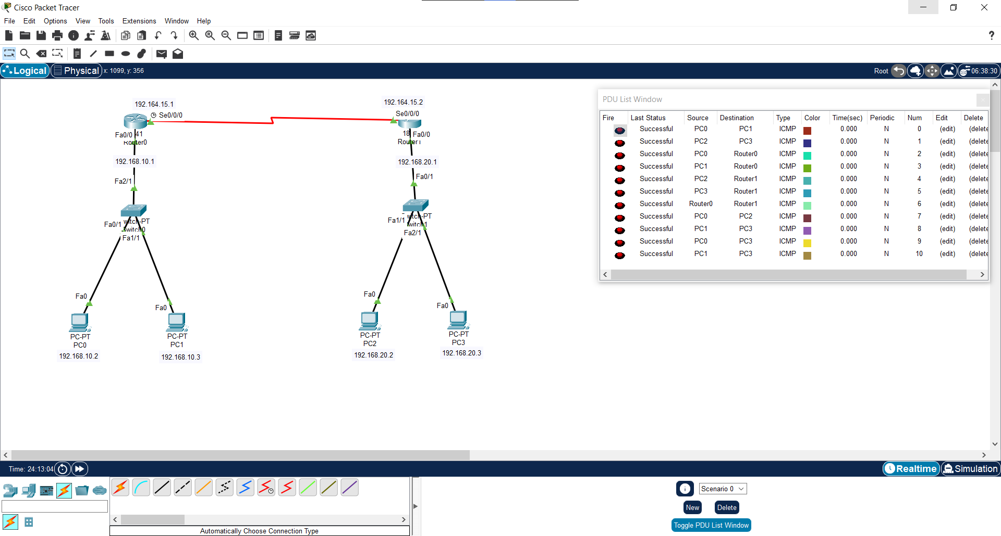**Main:**

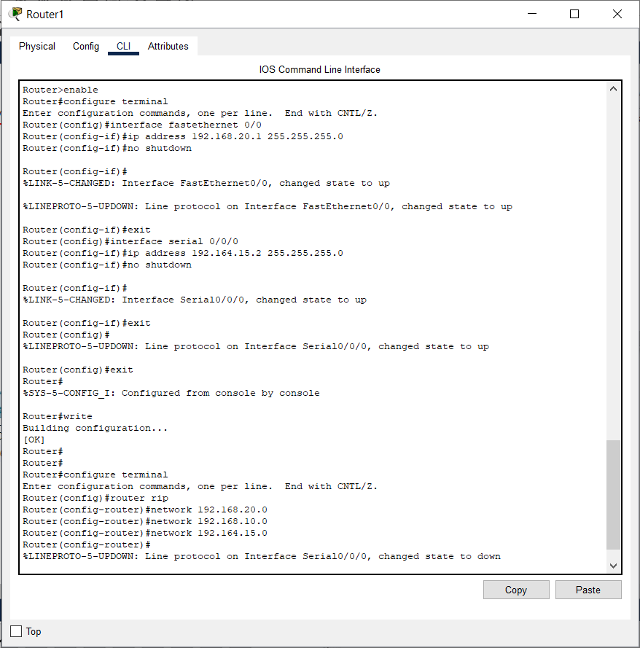**Router CLI Configuration:**

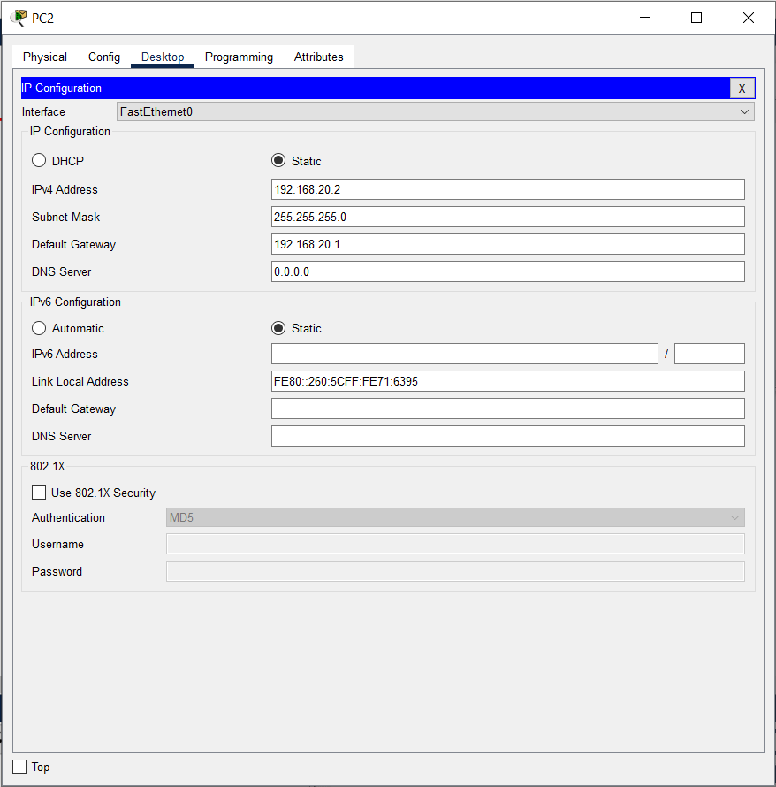**PC IPv4 Configuration:**

**Conclusion:**